|  |  |  |
| --- | --- | --- |
|  | October First Thursday Match  **Stage 4**  **Don’t Get Confused**  Designed by Ike Starnes  Credit to Harley Wiegert Georgia Practical Sporting League |  |
| **START POSITION:** Standing outside the shooting area with toes on rear fault line of middle shooting box.  **HANDGUN:** Handgun is unloaded and holstered with wrists above shoulders.  **PCC:** is unloaded, with stock on belt, weak hand wrist above shoulders, muzzle pointed downrange. | | **SCORING:** Comstock, 22 rounds, 110 points  **TARGETS:** 11 USPSA paper targets  **SCORED HITS:** 2 Best hits per target will be scored  **START-STOP:** Audible - Last shot  **RULES:** Current USPSA Rules |
| **STAGE PROCEDURE:** Engage targets from within the shooting area. | |

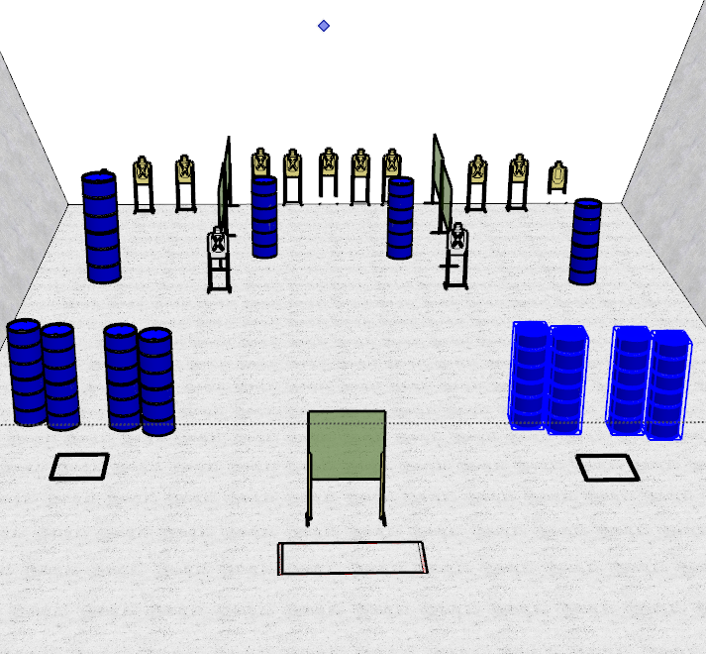

**WRITTEN STAGE BRIEFING:**

**Stage 4 – Don’t Get Confused** is a 22-round, 110 point, Comstock Long Course. There are 11 USPSA targets and the best 2 hits per target will be scored.

**Handgun start position** standing outside the shooting area with wrists above shoulders and toes on rear fault line of middle shooting box. Handgun is unloaded and holstered.

**PCC start position** standing outside the shooting area with toes on rear fault line of middle shooting box with weak hand wrist above shoulders. PCC is unloaded with muzzle pointed downrange.

On the audible start signal, engage targets from within the shooting areas.